Sky Castle
123
International Marketing
The Analysis of Poland
21st, June, 2024
Professor
James Stanworth

Presented by
Angela S1163029
IChen Liu S1163009
Janet S1163079
Celeste S1062034
Wayne S0963045
Jackson 0963051

Table of contents
Introduction ......................................................................................................... - 3 -
Goals.................................................................................................................... - 3 -
Characteristic of product...................................................................................... - 3 -
STP....................................................................................................................... - 4 -
Segmenting ...................................................................................................... - 4 -
Targeting .......................................................................................................... - 5 -
Positioning ....................................................................................................... - 5 -
Pricing ................................................................................................................. - 6 -
Promotion ........................................................................................................... - 7 -
Supermarket ......................................................................................................- 7 -
E-commerce...................................................................................................... - 7 -
Social media...................................................................................................... - 8 -
3P ........................................................................................................................ - 9 -
People ............................................................................................................... - 9 -
Process ............................................................................................................ - 10 -
Physical evidence ........................................................................................... - 10 -
Conclusion ........................................................................................................ - 11 -

Introduction
- Coffee tasting symbolizes differences in economic status and taste, so we choose specialty coffee grown in Alishan, Taiwan.
- Combining the sweet aroma of brown sugar, the fruity aroma and the aroma of tea, we promote the oriental flavor coffee of subtropical islands to Poland.
- We sell it in hanging drip coffee pods because drip brewing intensifies the complexity of the coffee's flavor and brings out the subtle flavors and aromas.
- We use aluminum foil bags as outer packaging because it can block moisture, air, and light, extending the shelf life of the package contents.
Goals
To achieve our goal—successfully marketing our coffee in Poland—we will analyze the market segments in Poland and choose the most suitable segment to develop marketing strategies. We will understand what Polish people truly want and design our products accordingly.
Characteristic of product
- High-quality
Our coffee uses high-grade Arabica beans and is roasted light or medium to bring out different flavors in the coffee.
- Taiwanese characteristics
Our coffee beans are grown in Ali Mountain, where the beans have a sweet taste and a tea fragrance.
- Convenient
- We sell it in hanging drip coffee pods, which offer a simple and convenient brewing method.
- Flavor
- Our coffee is tailored to Polish tastes. Data1 shows that they enjoy lattes and cappuccinos, both of which are on the sweeter side. Therefore, we choose brown sugar, fruity aroma, and tea aroma as the flavors of our coffee.
- Package
Our packaging adopts a simple, high-quality style.
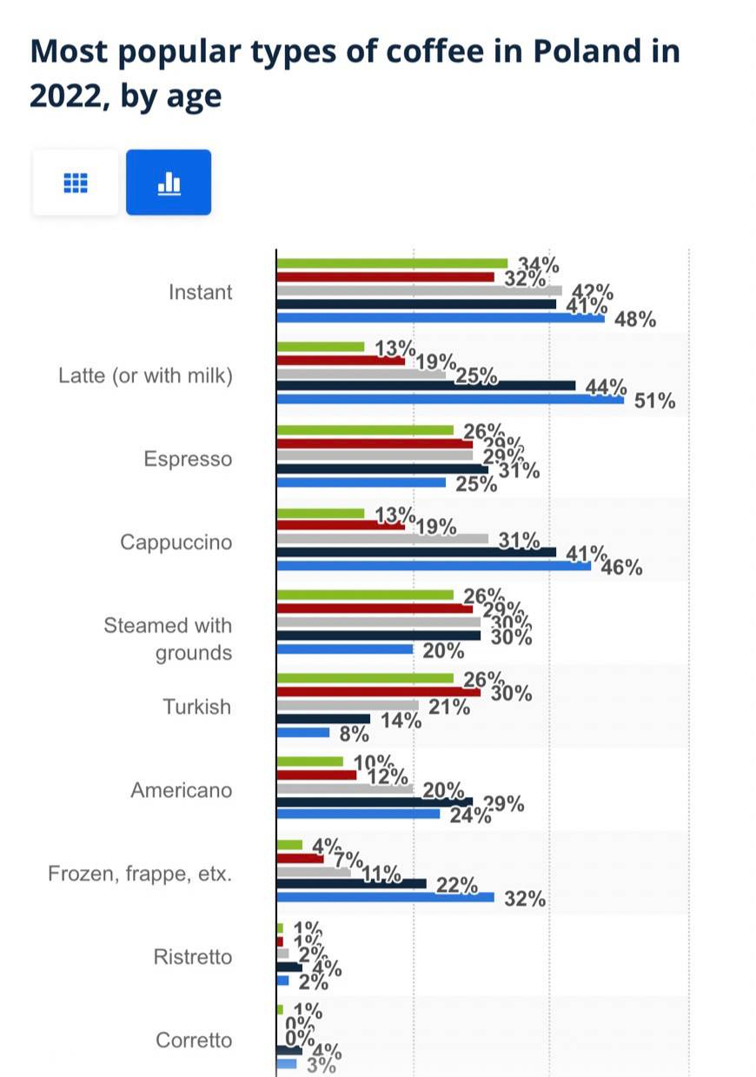Data1
STP
Segmenting
- Geographic: In terms of geography, we segmented Poland into industrial area, suburb area and urban area according to the main industrial types of different cities.
- Demographic: In the demographic part, we use 18 years old and 60 years old as the dividing line to divide Polish population into teenager, adult and elders. In addition, we also divided Polish population by gender into male and female.
- Psychographic: Finally, in the psychological part, according to the degree of preference, it is divided into light roast, medium roast and dark roast.
And we divided the Polish lifestyle into high quality, leisurely life, low-paced and fast-paced.
Targeting
Our target customers are females with high quality who lives in urban. Women in this range have a better quality of life, so they can pursue higher-priced and better products.
Positioning
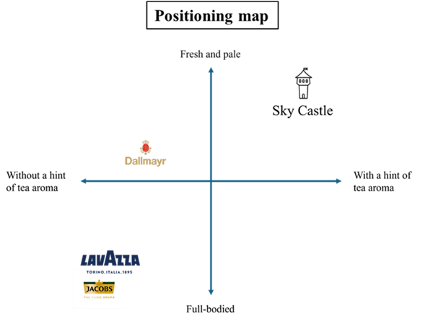
Let's start with data provided by Statista. The data indicates that in 2023, the most popular coffee bean brands in Poland are Lavazza, Dallmayr, and Jacobs. Therefore, we have created a positioning map with these three companies as competitors.

As shown in the diagram, we have positioned our brand as having a hint of tea aroma and a fresh and pale flavor. Although Poles love drinking coffee, tea is also an essential part of their daily life. In Poland, tea is very popular, and people often enjoy a cup of fragrant tea in the morning or during afternoon teatime. Therefore, we believe that coffee with a hint of tea aroma should have strong competitive potential.
Additionally, we are targeting our product towards adult women. We believe that, compared to strong flavors, many women might prefer to try coffee with a lighter and more refreshing taste. In a market dominated by strong-flavored coffee in Poland, we will be the best choice for those seeking a different, lighter coffee experience.
Pricing
Alishan coffee represents the pinnacle of coffee excellence, blending quality, rarity, cultural significance, and a delightful taste experience adored worldwide.
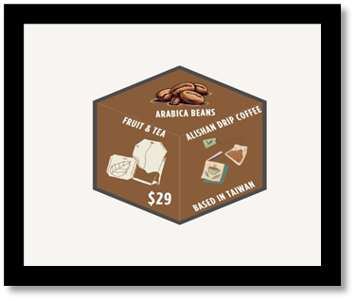
We have opted for a value-based pricing strategy combined with competitive analysis for the market. Based on the factors mentioned, we priced our product at $29 for 10 packs, which is the most sensible approach to pricing Alishan drip coffee in the market. This method allows us to maximize the perceived value of the product while ensuring that the price remains competitive. Consequently, we can optimize profits and build a strong, trustworthy brand in the eyes of consumers.
Promotion
- Supermarket
We will set up a stand in the supermarket to make customers take a sample and choose a common supermarket, Biedronka. In daily life, everyone buys something in there. This is a good opportunity to contact customers.
- E-commerce
According to Polish media, 62% of online users in Poland will search for goods or buy goods online through the Internet. In Poland, the most popular e-commerce platform is Allegro. Its brand awareness is as high as 98%, known as the Polish version of eBay.
Therefore, we place advertisements about our coffee on Allegro. When consumers are looking for a keyword for a certain product, it often pops up a row of graphic commodity advertisements at the top. This advertisement can catch the attention of consumers at the first time and be further developed potential customers.
- Social media marketing
According to a research in 2022, it has about 27.2 million social media users (and it is still growing rapidly) , especially females. This picture shows that.
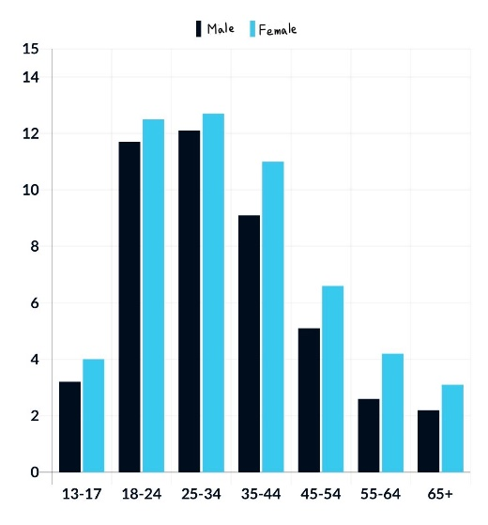
In addition, Polish users generally use Facebook and like it the most. These two pictures shows under the sentence.
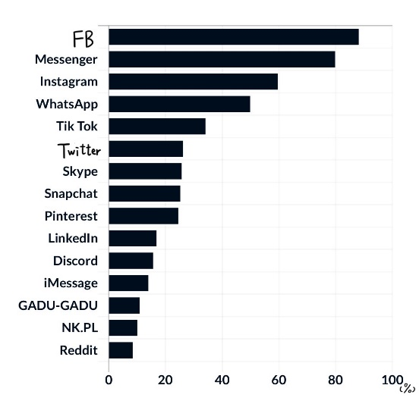
The most commonly used social media in Poland.
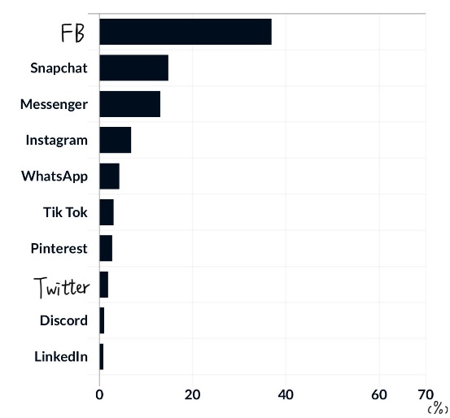
Polish users’ favorite social media.
Because of the result, we try to market on Facebook. First, we set female as our target audience. Next, set up a fan page. Third, we need to think creative ideas, like shorts or interesting copywriting, and post our coffee continuously. This way avoid decreasing fans and attract potential customers . Finally, Research competitors is also important. We can study the same type of fan page and take a look at the articles they posted. But we have to make some difference with the coffee competitors.
3P
People
Personnel training is also a very important part of marketing.
- Our sales staff are responsible for interacting with customers. They have good communication and customer service skills, allowing them to effectively promote our coffee.
- If there is a problem with the product, our customer service will listen carefully to the customer's needs and opinions, provide clear solutions to the problem, and maintain a professional and friendly attitude during the communication process.
Process
Some issues may arise during the implementation process.
- Customers may doubt or be unsatisfied with our product: Establish clear communication channels for inquiries and issue resolution, ensure rigorous quality control before shipping, seek prompt feedback on flavor, and use this feedback to maintain consistent product quality.
- Regarding product delays or issues with flavor: Optimize shipping methods and use high-quality packaging to preserve the coffee's flavor and freshness during transit.
- There are any unforeseen issues: Promptly acknowledge the issue to demonstrate responsiveness and concern, and if appropriate, offer a sincere apology to show humility and accountability. Propose a resolution that aligns with the customer’s needs and expectations, and follow up after resolving the issue to ensure their satisfaction and maintain goodwill.
Physical evidence
- To give customers a better experience, we will include product introduction and features of drip coffee in the packaging, so that customers can better understand our products and have a deeper connection with our products.
Conclusion
Connected with the word "elegance", we provide Polish women with sweet, fruity and tea-flavored coffee, allowing them to beam with delight as they enjoy the wonderful coffee.

https://polishgrammar.com/life-in-poland/comment-page-2/
https://www.statista.com/statistics/1193963/poland-favorite-brands-of-coffee/
https://www.kafed.com.tw/alisan-coffee-beans/
https://www.17cross.org.tw/Km/km_more?id=0a66151b508c4952b65da2defdad7d5c
https://glints.com/tw/blog/marketing-and-advertising-introduction-of-google-ads/
https://zh.oosga.com/social-media/pol/
https://glints.com/tw/blog/facebook-marketing/

